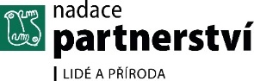
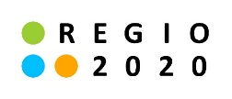
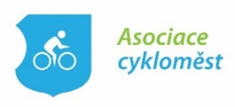
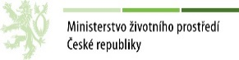
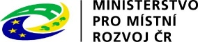
The Czech Ministries of Transport and other partners,
the Czech Ministries of Regional Development and of the Environment together with the Czech Association of Cities for Cyclists and the Partnership Foundation
prepared
THE CONFERENCE
Urban Mobility Academy

Date:
October 4 – 5, 2018
Venue:
Hotel ATOM, Velkomeziříčská 640/45, Třebíč
PROMOTED BY
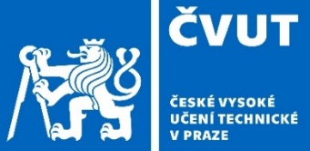
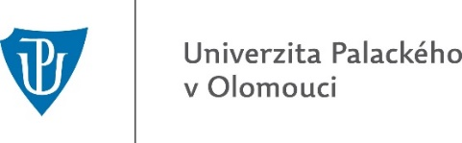
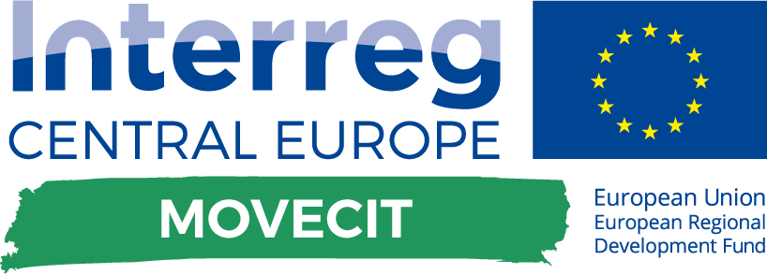
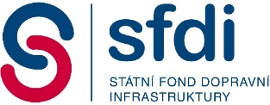
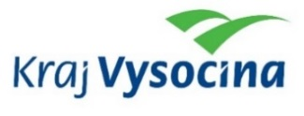
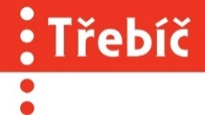
EXPERT GUARANTEES
ABOUT THE CONFERENCE
European countries view the SUMP as a strategic document that includes the following aspects: Mission - Vision - Strategic Goals - Specific Goals - Measures - Action Plan, where the Action Plan is a key aspect, defining by whom and when the specific steps will be implemented, and what the costs will be. SUMP is primarily a concept which defines where the future city should head towards. It means a good action plan is also needed to achieve the strategic goals.
To improve mobility plans in Czech towns and cities we need to know more about the problems concerning developing the sustainable urban mobility plans, and to be able to discuss them openly. It should be highlighted that the purpose is not to criticise, but to improve things using a principle "I'm learning through doing things". The conference is based on exchange of experience and sharing of good practices between towns and cities, including not only achievements, but also setbacks or mistakes as necessary parts of every good project (e.g. the transformation of the Mariahilfer Strasse in Vienna). Although we use the same processes in the Czech Republic, do we always see the essentials?
During the conference, special attention will be paid to strategic management. As the SUMP is often confused with (just differently called) general urban transport plan, the conference will try to explain that it is first of all a strategic document, and what strategic management means in the SUMP context. To develop such documents requires involvement of professionals from both technical and humanitarian fields and disciplines.
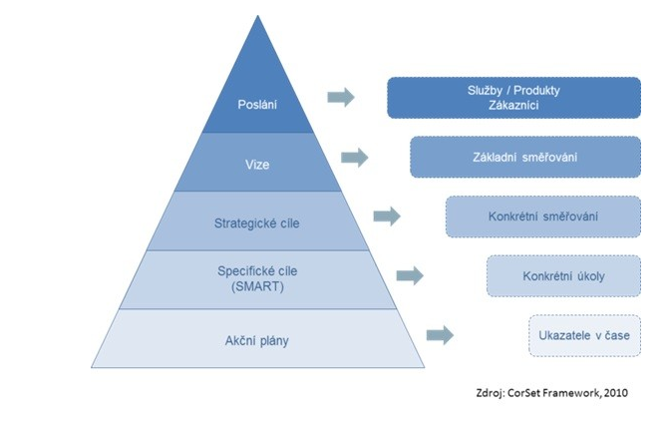
The Czech Republic (through the Czech Ministry of Regional Development) has become a co-coordinator for the Partnership for Urban Mobility project (PUM) since January 1, 2017. PUM is one of the twelve projects developed by the Urban Agenda for the EU. More details can be found at https://ec.europa.eu/futurium/en (the link Urban Agenda for the EU). Our aim is to establish a similar partnership at the national level and to present related topics at the conference. The Partnership for Urban Mobility deals with many measures, including the development of the SUMPs.

The conference will build upon an interactive training programme (the description see at http://www.dobramesta.cz/aktivni-obcan) as well as upon experience from the European MOVECIT (https://www.interreg-central.eu/MOVECIT).
CONCLUSIONS
In 2019-2020 the Czech Transport Ministry in cooperation with other ministries wants to develop a new government strategy for urban mobility development; the collection of impulses and suggestions was initiated at the conference of the Urban Mobility Academy which took place in the Czech town of Třebíč on 4th and 5th October 2018. The conference was also full of suggestions useful for politicians at the local level on how to support urban mobility.
Block 1 = Reminding the SUMP preparation and implementation processes
Sustainable Urban Mobility Plans (SUMPs) have been familiar to the Czech towns and cities for some time. The Czech SUMPs are based both on foreign and Czech methodologies, documents and examples. For the theory please look at the Urban Mobility Academy website (www.dobramesta.cz). Examples of the SUMP development, namely from the towns of Třebíč and Litoměřice, were also presented at the conference. A Hungarian expert András Ekés talked about Hungarian towns and cities and their experience with SUMPs which might be close to the Czech context. The most interesting were his good practice examples of working with children and selection of measures to be part of the action plan. Comments on the presentation see here.
Conclusion - there's no need to rediscover America...
Block 2 = SWOT analysis of the SUMP development and implementation, or: We must admit that the processes sometimes don't work. We live in the CR and cannot just copy some of the good practises that are successful in other European countries. Also, the 11 principles important for the urban mobility development were presented at the conference.
To make improvements in the SUMP processes in our cities we need to know and discuss as much as possible about related problems. The main goal of such a discussion is not to criticize but to work hard on improvements, based on the principle "I learn through working". The presentations were built on real examples that show not only achievements but also partial failures and mistakes - an integral part of every good project (e.g. the reconstruction of the Mariahilfer Strasse in Vienna). Although there are similar processes in the Czech towns and cities, sometimes we may miss the essentials.
Every conference has usually a tight schedule and there is only a little or no discussion time. This is why a workshop was held in the Czech village of Javoříčko on 25th and 26th September 2018, where some of the conference issues were discussed in advance. The workshop, which was organized by the Czech Transport Ministry together with the Association of Cities for Cyclists, the Faculty of Transport of the Czech Technical University in Prague and the Dutch Embassy in the CR, gave the lecturers an opportunity to refine their performance.
The conclusions of this Block 2 were thus defined in Javoříčko. The discussions were focused primarily on the 11 principles that would be the basis for further urban mobility development. For details see in Annex 1
Block 3 = Three inspirations for the new strategy
It is recommended to use the following inspirations for the development of the new government strategy:
- The Partnership for Urban Mobility project where the Czech Republic via the Ministry of Regional Development works as a co-coordinator. Find more information here or on https://ec.europa.eu/futurium/en („Urban Agenda for the EU“). The project defines various issues and topics that could be possibly included in the new strategy. Moreover, it is recommended to apply the partnership of stakeholders on the national level too.
- The Strategic Framework for the Union of Towns and Municipalities of the CR (UTMCR) for the Smart City issues. The project is coordinated by the UTMCR together with the National Center for Energy Savings and other partners. The project will focus on Smart Services that are provided by the public sector at the local, regional and national level. Some of the towns and cities feel it as a problem that they are pushed both into Smart strategies and into making SUMPs. It was the town of Třinec which has shown in its presentation how to successfully combine both (see the presentation in Block 2).
- An integrated approach to addressing the issue. There were three presentations of companies that has shown how important it is to combine the interests of involved organizations, e.g. for a planned terminal or in shared economy.
Block 4 = Participation of the public and of companies in the development of the new strategy
The last block presented experience of the European MOVECIT project (https://www.interreg-central.eu/MOVECIT) and examples of the public participation in the SUMP processes (inlc. the corporate mobility plans).
Also, the communication strategy and the design of the City Changers campaign was introduced there which is aimed to support citizens in their active participation in the processes of changing the transport and mobility in their city. To have a successful campaign, we need to find and interconnect active citizens in every town and city, with the aim to make a group of so-called "satisfied" people who usually don't speak in the moments that are decisive for their town/city, and their voices and opinions are defeated by the shouting minority. This campaign was also discussed during the workshop in Javoříčko.
The report about the City Changers campaign please find in Annex 2

Annex 1 What we still don't know about promotion of urban mobility and cycling?
40 experts from the Czech Republic enjoyed the opportunity of having a discussion on New Urban Agenda and Cycling with Ruben Loendersloot of the Dutch Cycling Embassy. This event took place in the Czech village of Javoříčko on September 25 and 26, 2018.
The question is: How could the seminar be helpful to the Czech experts, when they know well all they need to know? Could the Dutch expert teach them anything useful?
And the answer is: The Dutch expert was here not to present and teach some revolutionary ideas, but to help us understand an innovative approach of looking at well-known issues from a new perspective and in new contexts. The discussion was largely interactive, since it was built not only on the Dutch experience but also on the Czech one represented by the town of Uničov.
The discussion on the first day resulted in 11 principles that will be fundamental for further development of urban mobility and cycling. See below brief conclusions of the six-hour discussion. It's just a fraction of what was said in Javoříčko.
- Strategy – although every city may need a 900-page strategy document, we should consider whether it's comprehensible also for the citizens. The city should transform it into a one-page text that is much more useful for the public.
- Knowledge –t's good to be rich in information and knowledge but the source is equally important - capacities on the one side like professors, planners, officials or technical literature, general public on the other side like children, teachers, employees, seniors, etc. Are we able and willing to accept the latter? It should not be a phrase. In the Czech Republic, such approach was applied for the first time in the Cycling Development Strategy for the Central Bohemian Region 2017-2023. Suggestions of students from the city of Český Brod can be found at the very end of the document - see p. 119 in the enclosed document. Well, no one has taken them as a serious source so far; anyway, we are eager to develop the trend and we believe that the lay voice of not only the younger will be heard.
- Courage –e must admit that the issue of sustainable urban mobility is an unpopular political topic. And to talk with the public about unpopular issues (that need to be addressed and resolved anyway) requires courage for every politician.
- Perseverance – it's impossible to settle the urban transport problems in one day, one year, or in one polling period. We need long-term visions that require lots of perseverance. This is another topic in the new government strategy.
- Experience – this English term offers many options when being translated in Czech. It also symbolizes of our fixation on subjective experience, when we often forget these are no communicable. The question then is what actually the "good practice" means.
- Research – does research belong exclusively to research companies? Yes, but are they able to use also the data of the non-professional public? Or even support them with smaller grants?
- Commitment – can you imagine e.g. a press conference at the national or regional or local level called "Our ambitious plan is to build 1000km of cycle paths and we know how to do it"? It's just about sending a clear message to the citizens that we are serious about making changes.
- Marketing/community/mindset – the city of course must have a developed and sophisticated communication / marketing strategy but on the other hand the strategy must be based on local activities, local groups involvement and on an innovative approach to sustainable mobility. This also connects with proper education which should start at kindergartens and primary schools. And we don't mean the traditional transport trainings for children, but an active education to active mobility (which of course requires adequate infrastructure).
- Early adopters – cities should find their ambassadors not among politicians or officials, but from the public.
- Smart policy making – we keep talking about Smart Cities, smart solutions, but we usually forget to mention smart policy with a win-win strategy when every political party can be the originator of the right solution.
- Strong included policy on all governmental levels – seriously meant changes in urban and regional mobility should take into account the fact that not only all the national, regional and local institutions are involved, but also some professional stakeholders, companies, and especially the public. We used as an example the presentation of the Olomouc Region which was presented at the Transport Committee of the Association of Regions on 21st September 2018. The presentation introduces a list of issues to be solved for the improved cycling development.
The seminar was organized by the Czech Ministry of Transport in cooperation with the Czech Association of Cities for Cyclists, the Transport Faculty of the Czech Technical University in Prague and the Embassy of the Netherlands.
The aim was to gain first incentives and suggestions for the new governmental strategy for the promotion of regional and local mobility.
Video here: https://www.facebook.com/cyklozlin/videos/301572853904202/

Annex 2 - Discussion about the City Changers campaign took place in Javoříčko
40 Czech experts gathered in the village of Javoříčko on 25 and 26 September to discuss the topic of New Urban Agenda and Cycling. The main organizer was the Ministry of Transport which is planning to prepare a new governmental strategy for regional and local mobility in 2019-2020, and is gaining now the first incentives and suggestions. The seminar was organized in cooperation with the Czech Association of Cities for Cyclists, the Transport Faculty of the Czech Technical University in Prague and the Embassy of the Netherlands.
The discussion on the first day resulted in 11 general principles that could be fundamental for further development of the strategy.
The second day was focused on the first steps to prepare the new strategy, with the aim of intensive public involvement.
For this purpose MasterCard has prepared a communication strategy and visualization of the City Changers campaign to motivate local citizens to actively participate in the process of changing mobility in their towns and cities (see the enclosed presentation MasterCard_Kampan_City_Changers).
If we want the campaign works properly, we need to find and interconnect active citizens in all towns and cities. The aim is to establish a community of so-called "satisfied" people who prefer to be silent in moments that are decisive for their cities, and they are usually routed by the "loud minority"; a community of City Changers that communicates via social networks and the www.citychangers.com.
The website refers to the conference City Changers which was held in Ostrava on 6 and 7 December 2017 and where the idea of campaign was born. The website is going to be transformed soon and will be just the tip of the iceberg of the overall communication strategy.
At the beginning, every active city or town gets their own website to have a space for communication with its citizens, sharing their ideas and views, and bringing incentives for various areas in urban mobility. And this is the important piece of news - offering citizens a chance of a two-way communication. The guarantor of correctness will be the Transport Faculty of the Czech Technical University in Prague and the Association of Cities for Cyclists. These institutions together with the city or town will provide the website with necessary information on urban mobility and will guide and mediate the citizens through a factual and proper discussion. Until now, such a discussion often fails.
The communication form during the City Changers campaign was presented in Javoříčko as a Dutch experience by Ruben Loendersloot of the Dutch Cycling Embassy, and also as the Czech examples of two Czech cities - Uničov (see the pilot website www.unicov.dobramesta.cz) and Třinec (see the presentation Javoricko_Kampan_City_Changers).
Here are some examples of the future admins: the website in Hranice will go to the pupils of the Drahotuše Primary School and to their parents, since this is the active group of people who participated in the transport seminar in the Castle Garden; in Třinec - students; in Hradec Králové and Kroměříž - active citizens.
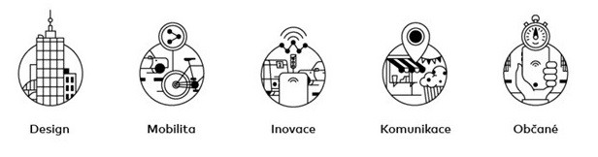
And what are the subjects to discuss? Here are some examples from the website of Uničov:
- street design - the layout of street space and public space http://unicov.dobramesta.cz/design_ulice
- mobility - divided into four areas: I am a person who daily/weekly uses different transport modes:
  - cycling: http://unicov.dobramesta.cz/cyklo
  - walking: http://unicov.dobramesta.cz/pesi
  - PT: http://unicov.dobramesta.cz/vlakbus
  - cars: http://unicov.dobramesta.cz/auta
- Innovations - everything connected with modern technologies: http://unicov.dobramesta.cz/inovace
- Communication - should be based on principles of a two-way communication strategy, which is symbolized by the following links at the Uničov website:
  - call to the citizens - "Join us", of course not only via the website http://unicov.dobramesta.cz/zapoj-se
  - Information for the citizens from the city (only a minimum amount) http://unicov.dobramesta.cz/aktuality
- Citizen - it's a human who lies in the centre of all activities. What would the new measures be for, if people don't use them; what would a great communication strategy be for, when there are no real changes following the discussion, or new commitments in relation to travel behaviour. All efforts should result in improvements.

